**Sukkur IBA University**

**Software Design Specification (SDS)**

For

**3D Brain-TAMP**

**(Development of 3D Brain through Taxonomy, Anatomy, Morphology, and Physiology)**

Version 1.4

Muhammad Hasnain, Sajjad Ali, Mujeeb Ahmed

Supervisor: Dr. Ahsanullah Abro

|  |  |
| --- | --- |
| ***Project Code*** | 19F-09 |
| ***Supervisor*** | Dr. Ahsanullah Abro |
| ***Co-Supervisor*** | N/A |
| ***Project Manager*** | Muhammad Hasnain |
| ***Project Team*** | Muhammad Hasnain  Sajjad Ali  Mujeeb Ahmed |
| ***Submission Date*** | February 2, 2023 |

Table of Contents

1. Introduction of Design Document 1

2. Entity Relationship Diagram (ERD) 1

3. Sequence Diagrams 2

3.1. View Brain Model 2

3.2. View Brain Information 2

3.3. Take Quiz/Assessment 3

4. Architecture Design Diagram 4

5. Database Diagram 5

6. Class Diagram 5

7. Interface Design 6

8. Test Cases 8

9. Appendices 9

# Introduction of Design Document

The following is an introduction to the Software Design Specification (SDS) for the Final Year Project (FYP) entitled "3D Android Tutorial App using Unity." The app aims to provide a comprehensive and interactive learning experience for students studying the four perspectives of Taxonomy, Anatomy, Morphology, and Physiology. The purpose of this SDS is to outline the design of the app, including the architecture, user interface, and functionalities. The SDS will provide a clear understanding of the project's requirements and the technical solutions used to meet those requirements. This document will be used as a reference throughout the development process to ensure that the app is developed in accordance with the specified design.

# Entity Relationship Diagram (ERD)

An ERD (Entity Relationship Diagram) is a type of diagram used to represent the relationships between different entities in a system, such as customers, products, orders, or transactions. ERDs are used to design and document the structure of a database and show the relationships between different tables and their attributes. They help in designing and maintaining databases and provide a visual representation of the relationships between different entities.

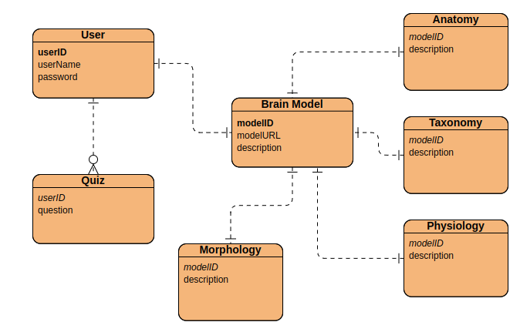

# Sequence Diagrams

Sequence diagrams are a type of UML diagram used to visualize interactions between objects and components of a system. They show the flow of messages between components, and can also indicate the state of each component. They are useful for designing and documenting complex systems and can help identify potential issues with system architecture or functionality.

## View Brain Model

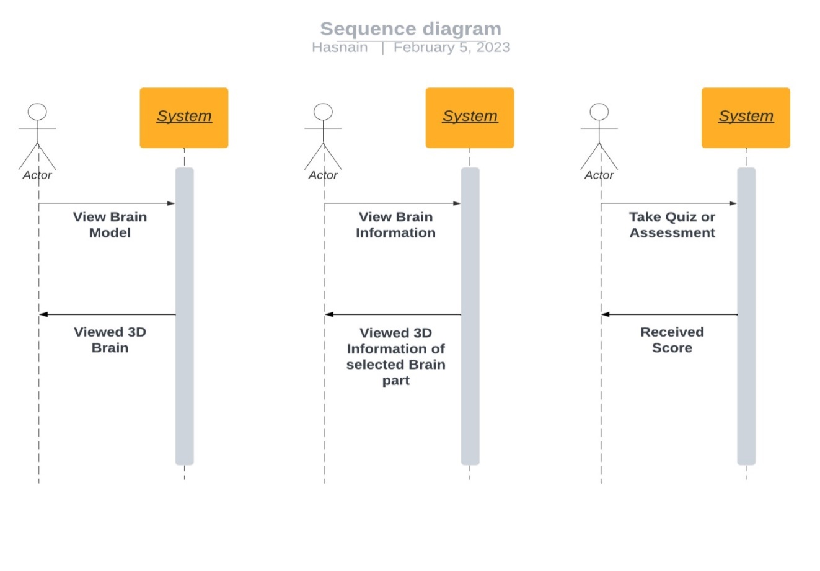

Figure 1: Sequence Diagram for View Brain Model

## View Brain Information

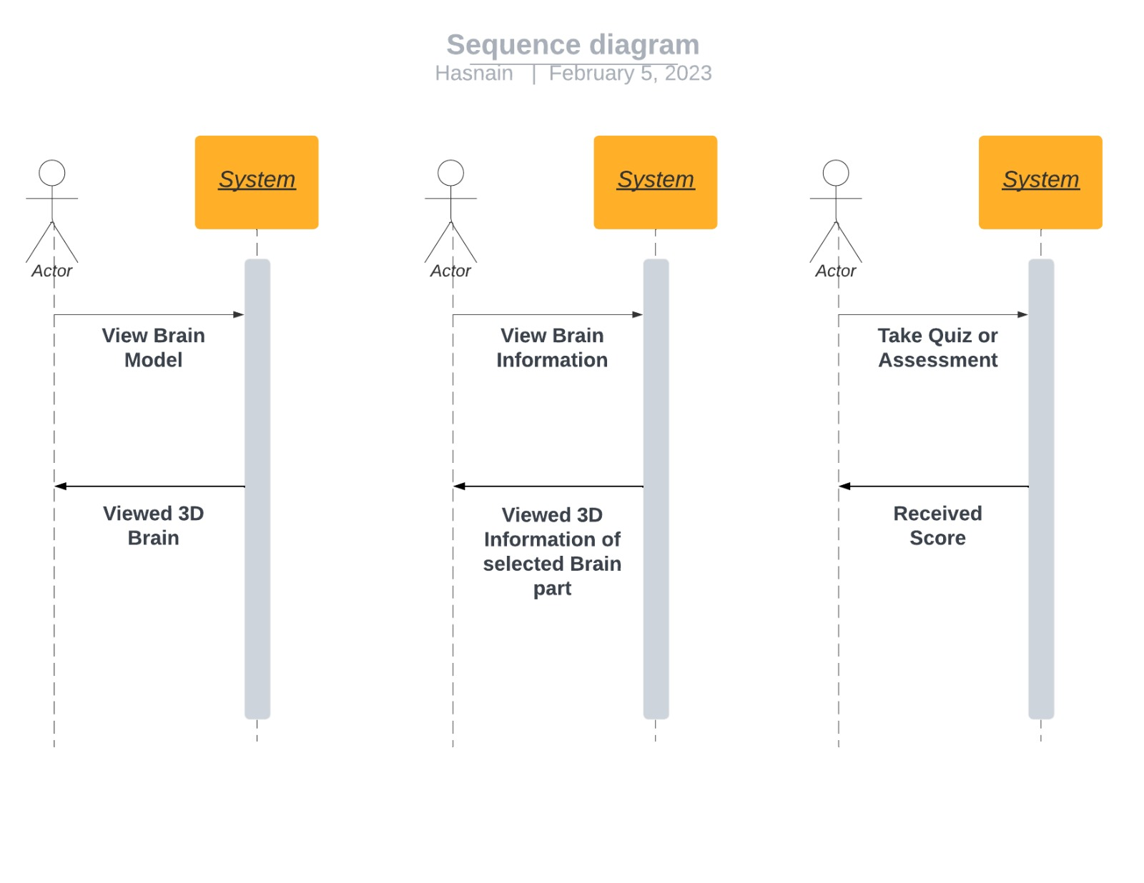

Figure 2: Sequence Diagram for View Brain Information

## Take Quiz/Assessment

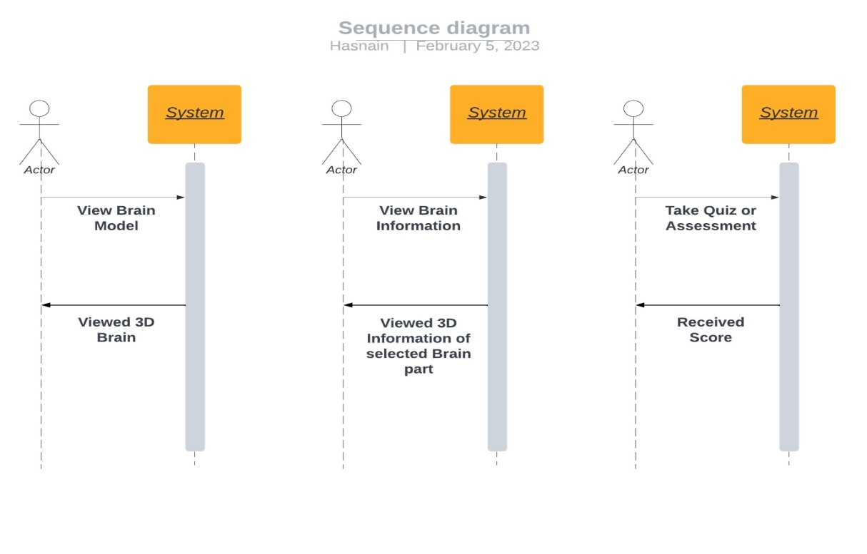

Figure 3: Sequence Diagram for Take Quiz/Assessment

# Architecture Design Diagram

Architecture design is the process of creating a high-level plan or blueprint for a system or application, which outlines the overall structure, components, interactions, and behaviour of the system. It aims to ensure that the system is scalable, maintainable, and meets the requirements of stakeholders. This process involves multiple stages, including analysis, design, implementation, testing, and maintenance, and may use various architectural patterns.

Figure 5: System Architecture

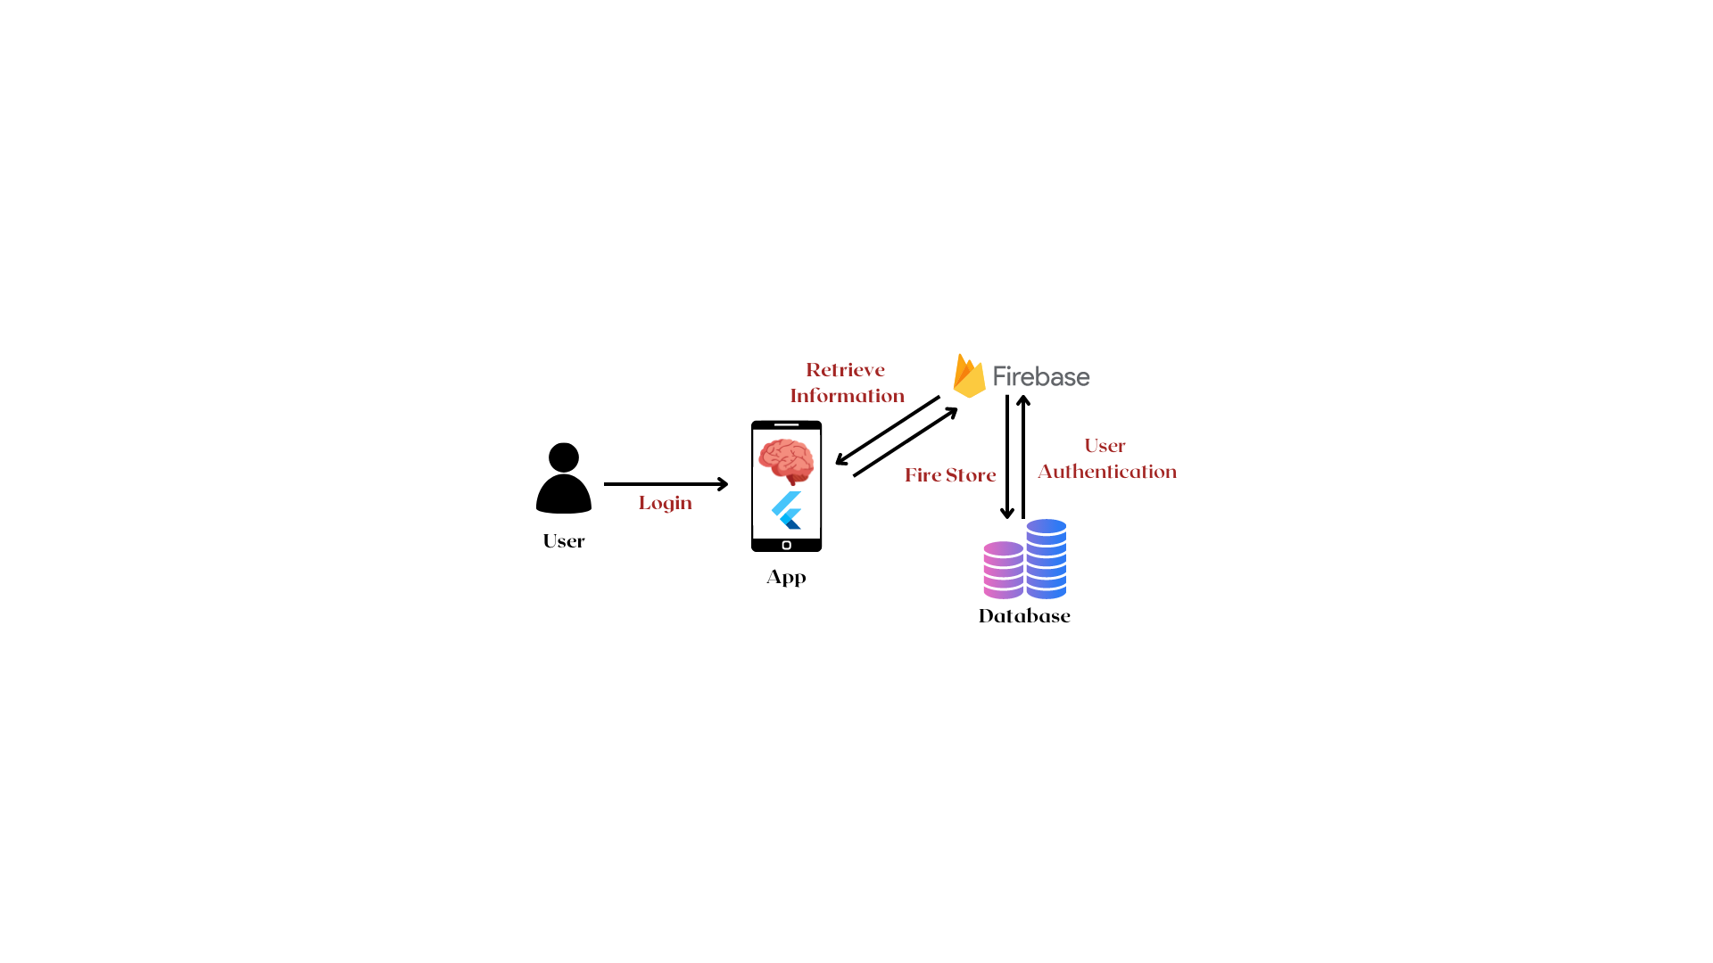

# Database Diagram

A database diagram is a visual representation of the structure of a database that shows tables, columns, relationships, and constraints between them. It is used to document the logical and physical design of a database and can help with database development, maintenance, and troubleshooting. Database diagrams can be created using various tools and are an important part of database design and management.

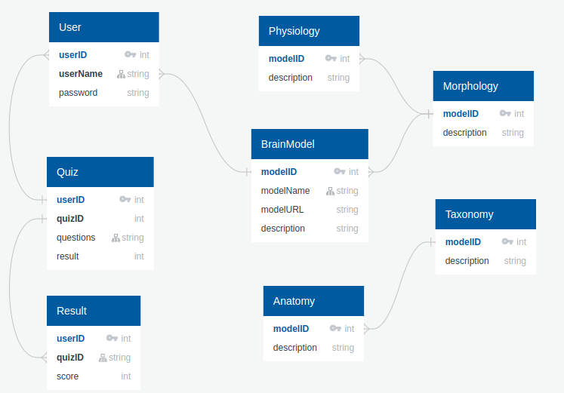

# Class Diagram

A class diagram is a type of UML diagram that represents the structure and behaviour of a system by showing the classes, attributes, methods, and relationships between different objects or components. Class diagrams are used to visualize the overall structure of a system, and are particularly useful for designing and documenting object-oriented software systems. They provide a high-level view of the system's architecture and can help identify potential design flaws or issues.

N/A

# Interface Design

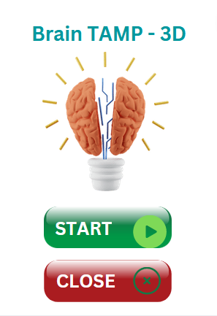

Figure 6 Brain Unpacked: Home Page

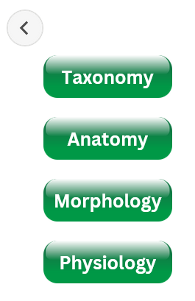

Figure 7 Brain Unpacked: Menu Page

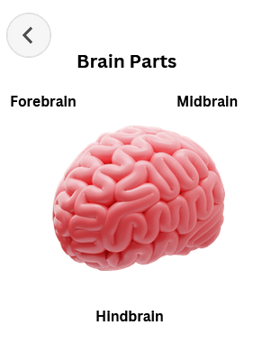

Figure 8 Brain Unpacked: Parts of Brain (Sample)

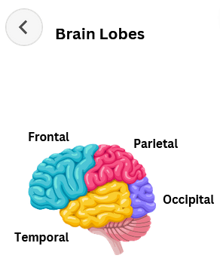

Figure 9 Brain Unpacked: Brain Lobes (Sample)

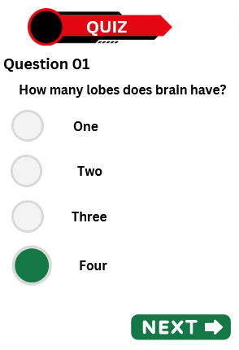

Figure 10 Brain Unpacked: Quiz Questions (Sample)

# Test Cases

Test cases are a set of instructions or procedures designed to verify the functionality or performance of a system or application. They are used to ensure that the system meets the requirements and expectations of the stakeholders, and that it works correctly under various conditions and scenarios. Test cases are typically created based on the system specifications and can include different types of tests, such as unit tests, integration tests, functional tests, and performance tests.

N/A

# Appendices

Figure 1: Sequence Diagram for View Brain Model 1

Figure 2: Sequence Diagram for View Brain Information 2

Figure 3: Sequence Diagram for Take Quiz/Assessment 2

Figure 4: System Architecture 3

Figure 5: System Architecture 3

Figure 6 Brain Unpacked: Home Page 4

Figure 7 Brain Unpacked: Menu Page 4

Figure 8 Brain Unpacked: Parts of Brain (Sample) 5

Figure 9 Brain Unpacked: Brain Lobes (Sample) 5

Figure 10 Brain Unpacked: Quiz Questions (Sample) 6